**Online Training for** 

How to Access the Wells Fargo Websites: <https://retailservices.sec.wellsfargo.com/>

**Log into the Online Resource Center with your stores designated login.**

**Access the Training Tab:**

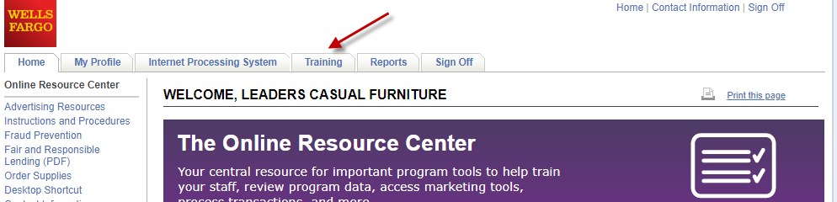

**You will then see courses available to you.**

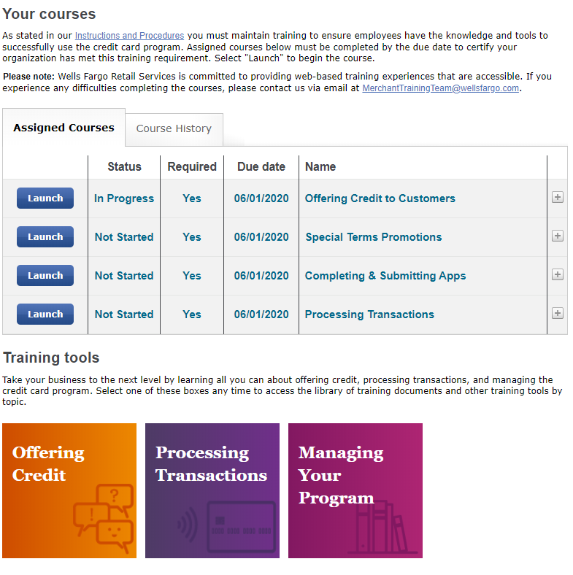

**When you Launce one of the Assigned Courses- you may see the warning below. Simply click on “Launch Course” to begin the lesson**.

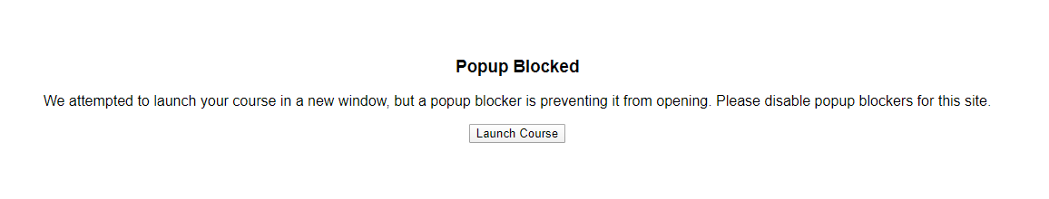

You will take All 4 of the Assigned Courses, as well as the Offering Credit training tool.

**Please note- Wells Fargo may make mention of other programs in their training tools; we currently only offer the 12 month or 36 month Financing packages**.